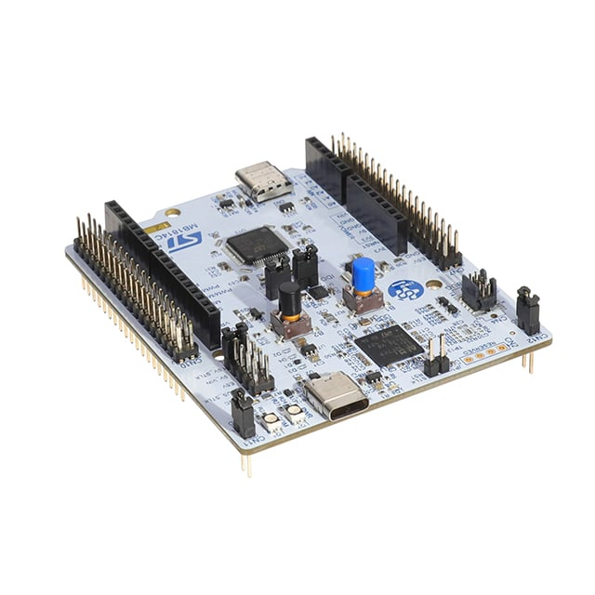 | COMPUTER SCIENCE DEPARTMENT  TE2004B – ADVANCED EMBEDDED SYSTEMS DESIGN  LAB #1 – GPIO
 | Name: _________________________  ID: _________________________ | Name: _________________________  ID: _________________________
 | Name: _________________________  ID: _________________________ | Name: _________________________  ID: _________________________

Instructions:

- (R) Connect a dip switch to pins PB[15:12] with external 330Ω pull-up resistors. Connect an LED in sink configuration to PB10 and a 470Ω resistor.

- Implement a program that meets the requirements depicted in Table A.2.1. Process the output in a single line without messing with any other pin different to those in the table. Example: GPIOA->ODR = (GPIOA->ODR & ~(0xF<<0) ) | 0x01<<2 only modifies pins PA[3:0] by clearing them and then setting PA2.

Table A.2.1. Specifications for Random Combinatorial system
PB15 | PB14 | PB13 | PB12 | PB10 (LED)
0 | 0 | 0 | 0 | OFF
0 | 0 | 0 | 1 | ON
0 | 0 | 1 | 0 | ON
0 | 0 | 1 | 1 | OFF
0 | 1 | 0 | 0 | OFF
0 | 1 | 0 | 1 | ON
0 | 1 | 1 | 0 | ON
0 | 1 | 1 | 1 | OFF
1 | 0 | 0 | 0 | OFF
1 | 0 | 0 | 1 | ON
1 | 0 | 1 | 0 | ON
1 | 0 | 1 | 1 | OFF
1 | 1 | 0 | 0 | OFF
1 | 1 | 0 | 1 | ON
1 | 1 | 1 | 0 | ON
1 | 1 | 1 | 1 | OFF

Upload into Canvas a report that includes:

Circuit schematic in a blue box.

Picture X.1. Schematic for problem #X

Commented code in a red box (do not place code screenshots here).

Listing X.1. Code for problem #X

Short description (no more than 10 lines) of the implemented algorithm on a yellow square.

Listing X.2. Description for problem #X

Screenshot/picture of the implemented system.

Listing X.3. Working implementation for problema #X

